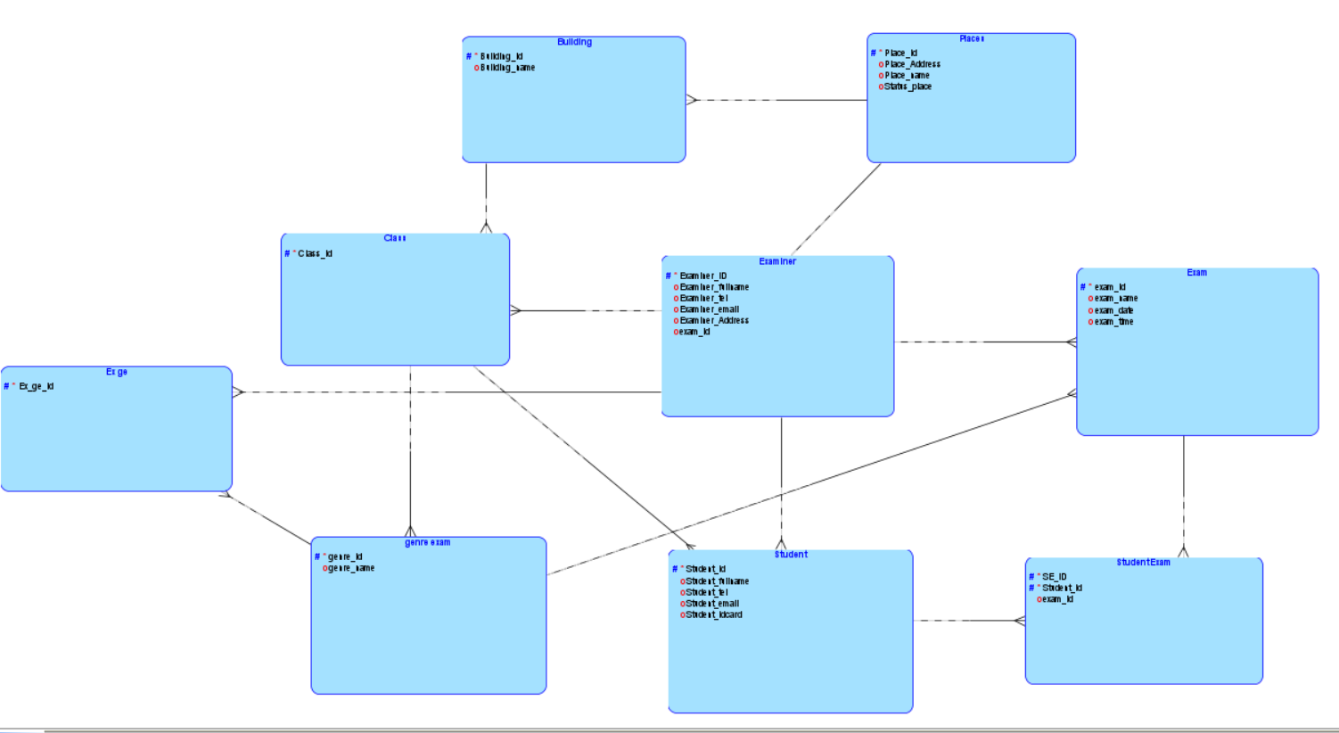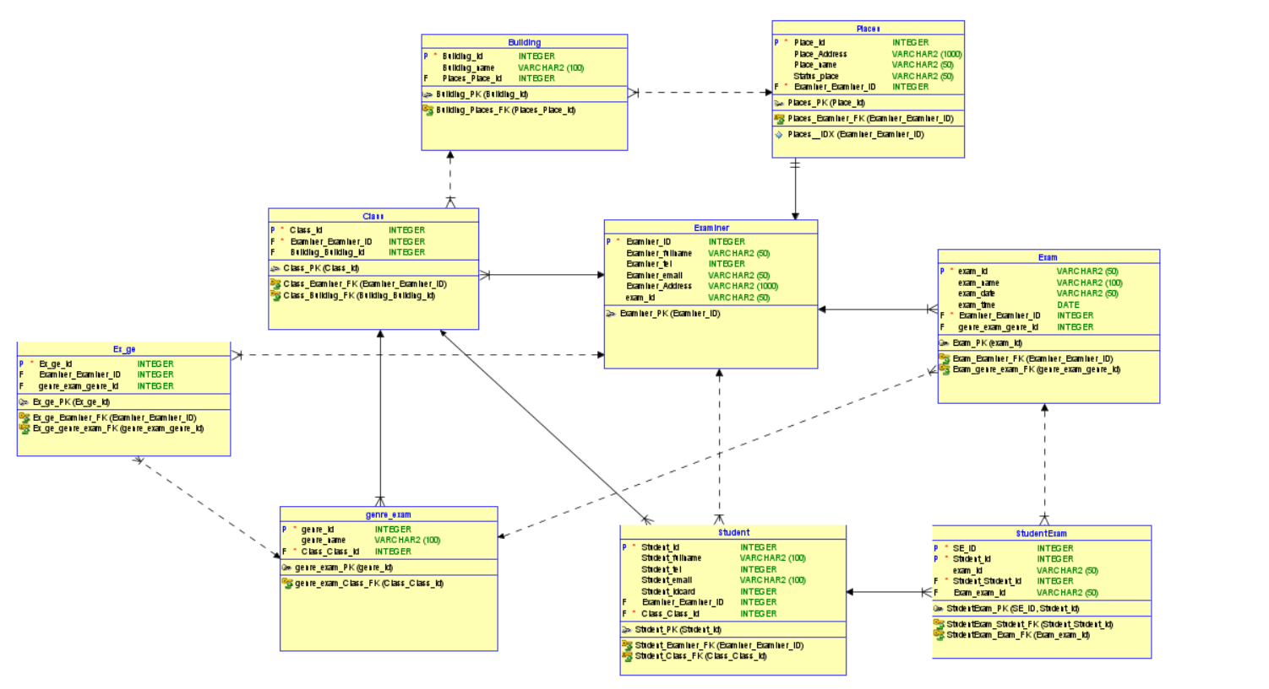

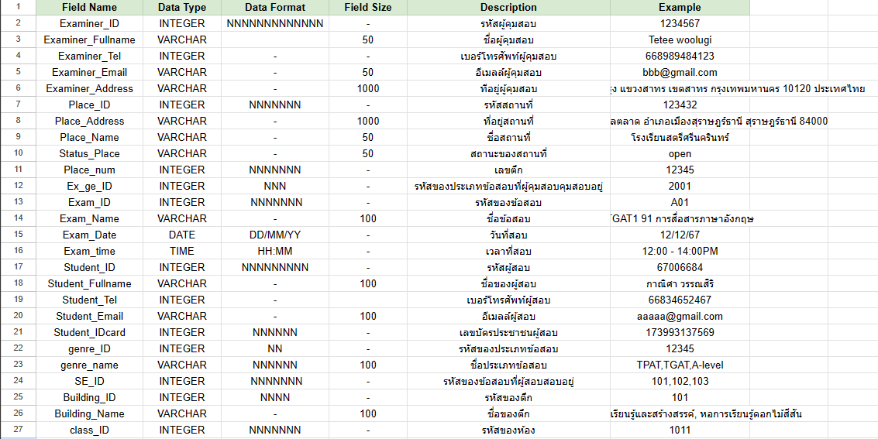

https://docs.google.com/spreadsheets/d/1IwiI_Ou_4fIQ32X4ZbGq6ZollLP-TOpmzKWPolp9Q-I/edit?usp=sharing

